**Dr. Babasaheb Ambedkar Technological University, Lonere**



In-plant Training Project report

On

**“MOLDED FIBER PRODUCTION MACHINE”**

**Carried out at**

**“PARASON MACHINERY INDIA”**

Submitted by

**Rohit Manoj Agrawal**

Under the guidance of

**Prof. Deepa Ravikumar**

Submitted in partial fulfilment of the requirement for the degree of B. Tech. in Mechanical Engineering

**Department of Mechanical Engineering**

**Marathwada Institute of Technology, Aurangabad.**

**Academic Year: 2022-23**



**CERTIFICATE**

This is to certify that the In-plant Training Project report entitled

**“Molded Fiber Production Machine”**

**Carried out at**

**“Parason Machinery India”**

Submitted by

**Rohit Manoj Agrawal**

**Roll No. ME4A01**

Has completed as per the requirements of

Dr. Babasaheb Ambedkar Technological University, Lonere.

In partial fulfilment of

Degree of B. Tech. in Mechanical Engineering

For the academic Year 2020-2021

|  |  |  |
| --- | --- | --- |
|  |  |  |
| **Prof. Deepa Ravikumar** | **Dr.P.U. Zine** | **Dr. N.G.Patil** |
| **Project Guide** | **HOD** | **Director** |

**Department of Mechanical Engineering**

**Marathwada Institute of Technology, Aurangabad.**

**Academic Year: 2020-21**

# **ACKNOWLEDGEMENT**

The internship opportunity I had with Parason Machinery India was a great chance for learning and professional development. Therefore, I consider myself a lucky individual as I was provided with an opportunity to be a part of it. I am also grateful for having a chance to meet so many wonderful people and professionals who led me through this internship period from March 16th to July 7th, 2022.

I express my deepest thanks to my mentor **Mr, Akhilendra Verma ( Head Maneger )** for taking part in useful decisions & giving necessary advice and guidance and arranging all facilities to make this internship easier. I choose this moment to acknowledge his contribution gratefully. I extend my grateful thanks to

**Mr. Madhure Desarda** (Operational Director) for providing me with the chance to work on this wonderful project which also aided me in conducting extensive study and learning about a bunch of new topics. I would also like to extend special thanks to the entire staff of Parason Machinery India for their full co-operation, guidance, and support during my internship.

I am also thankful to my Guide Dr. **Deepa Ravikumar** and the faculties of the Mechanical Department of Marathwada Institute of Technology, Aurangabad. for giving me the opportunity to complete this internship. **Dr. P. U. Zine,** Head of the Mechanical Engineering Department. Also we would like to thank, **Dr. N. G. Patil**, Director, Marathwada Institute of Technology Aurangabad.I perceive this opportunity as a big milestone in my career development. I will strive to use gained skills and knowledge in the best possible way, and I will continue to work on their improvement, to attain desired career objectives. Hope to continue cooperation with all of you in the future.

Date Rohit Agrawal

Place:Lonere

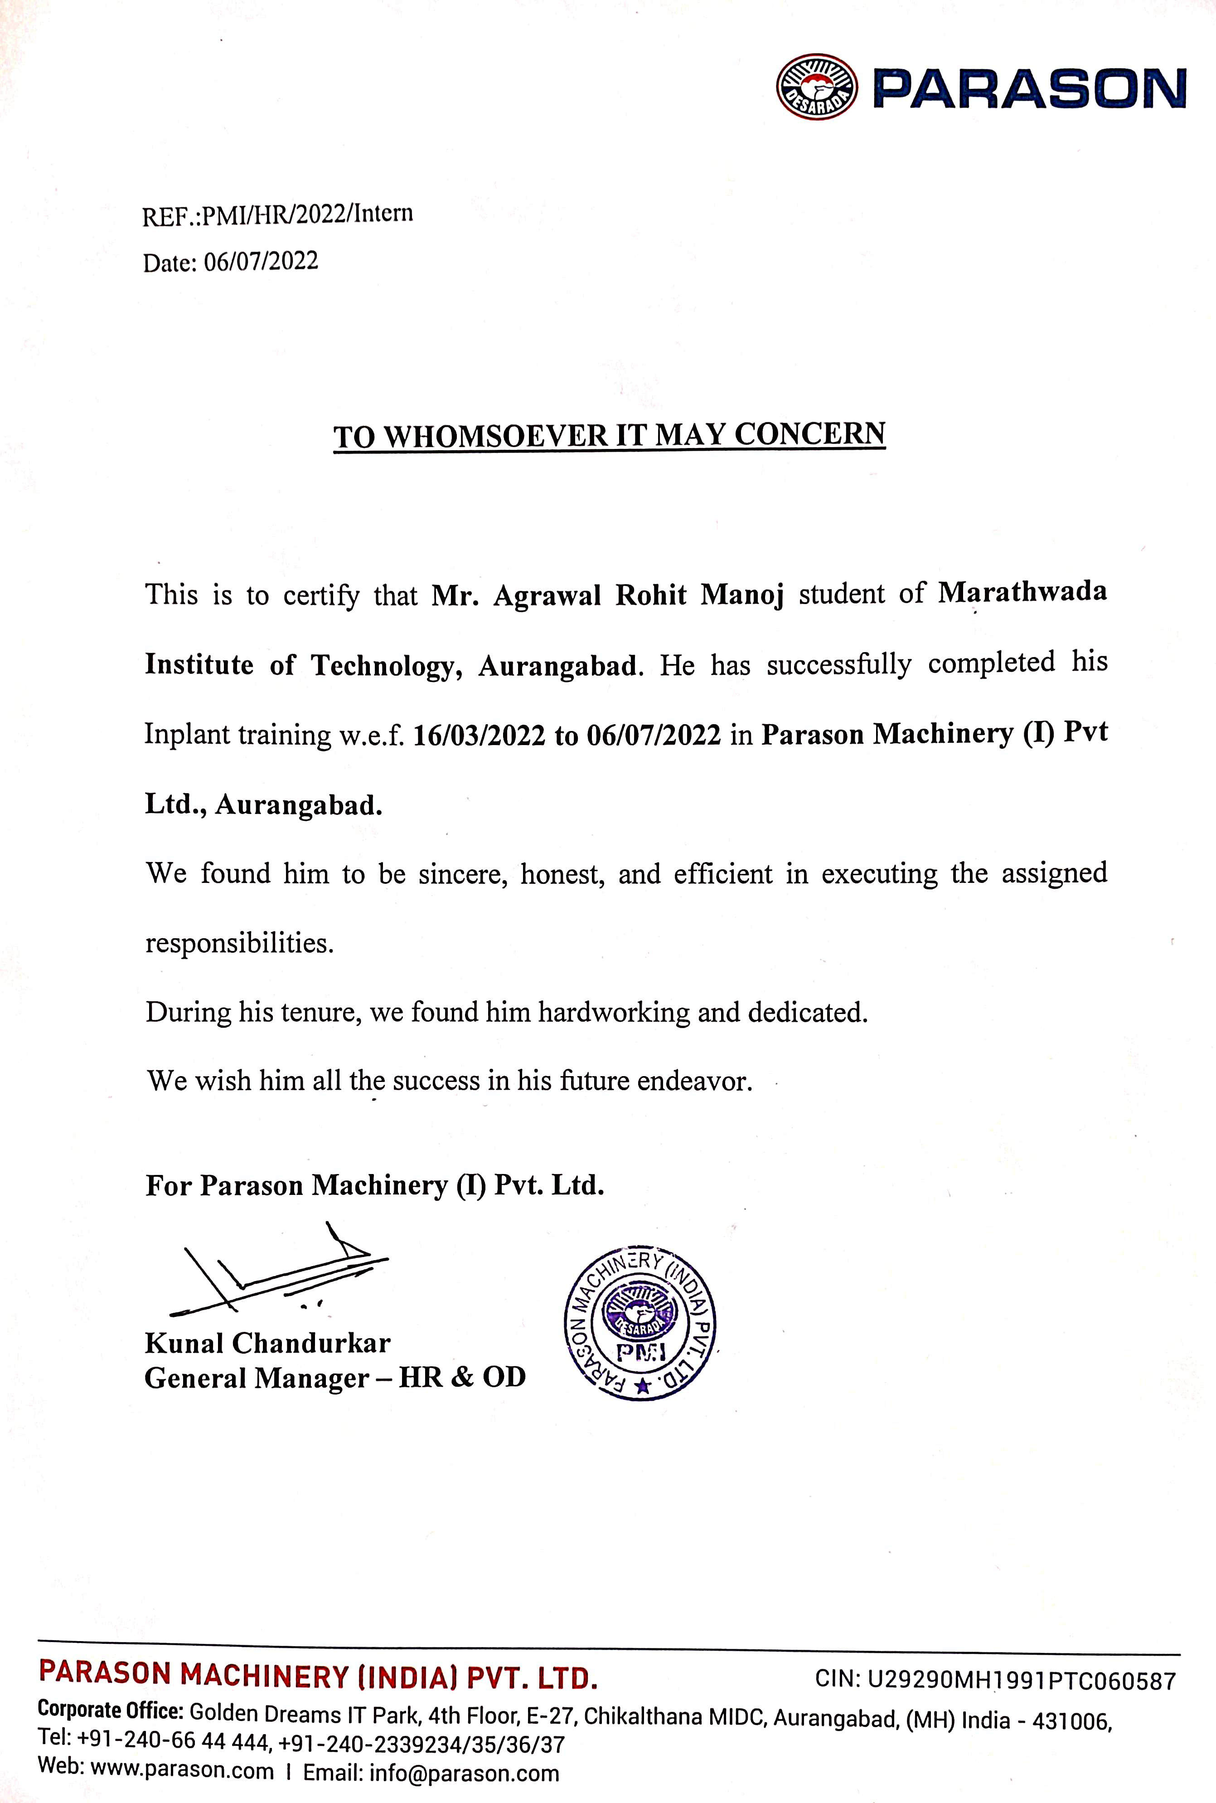

**INDEX**

|  |  |  |
| --- | --- | --- |
| **Sr. No.** | **CONTENTS:** | **Page**  **No.** |
|  | **Abstract** |  |
|  | **Introduction** | 7 |
|  | **Literature Review** | 10 |
|  | **Objectives** | 14 |
|  | **Methodology** | 16 |
|  | **Project Explanation**  1. Pulp Molding Production Machine.  2. Semi Automatic Forming Machine (Pfmv1).  3. Molded Fiber Edge Trimming Machine | 18 |
|  | **Result & Conclusion** | 33 |
|  | **Future Scope** | 35 |
|  | **References** | 37 |

**LIST OF FIGURES**

**Fig.Name**

Fig2.1 Envoirmental Baggase

Fig.2.2 Bagasse to Product

Fig.2.3 Molded Fiber Machine

Fig.2.4 Trimming Machin

Fig.6.1 Mold

**LIST OF TABLES**

Table 9. Products information

Table 10.1 Result62

MOLDED FIBER TABLEWARE PRODUCTS

Abstract

These molded fiber products are the best eco-friendly solution for an environmentally-conscious consumer. Manufactured under high-quality standards with the least Greenhouse Effects and Global Warming with zero-waste production, using natural gas for heat generation, the raw materials used are biodegradable & compostable, made from natural plant fibers such as Sugarcane Bagasse, Wheat Fibre or Bamboo Fibre, all of which are renewable resources. We are specialized in offering complete project engineering & solutions to produce biodegradable and compostable Moulded Fibre Products used in hospitals, corporate cafeterias, universities, restaurants, schools, homes, etc.All products are made from a renewable resource – Bagasse, which is the dry fibrous residue left out of agriculture waste. As with takeaway boxes, these plates and bowls are pressed into shape in a high-heat, high-pressure process. The result is an economic and sturdy selection of tableware which is more rigid in service than paper plates or bowls. These products are naturally compostable and suitable for hot, wet, and oily foods, offering superior performance to paper or EPS equivalents.

Thirdly, use the vertical or horizontal depithing machine deal the bagasse with the dry method of depithing, and the certified bagasse fiber for paper making is prepared.In the modern sugarcane bagasse stocking, it usually uses wet storage to replace the dry storage. Wet storage can keep the bagasse wet, the water content is 70-80%, and both control bagasse fermentation and keep high stock per unit area. After wet storage and pulp washing, the bagasse has features of good fiber quality and quick penetration of cooking liquor, which decide the quality of bagasse paper.

**CHAPTER 1**

**INTRODUCTION**

* 1. **MOTIVATION**

In recent years, the natural fibres have attracted substantial importance as potential structural material. Natural fibres are very fast replacing the traditional manmade fibres as reinforcements they have several advantages over manmade fibres. The abundant availability of natural fibre in India such as Jute, Coir, Sisal, Pineapple, Ramie, Bamboo, Banana, Bagasse etc. gives attention on the development of natural fibre composites primarily to explore value-added application avenues .Thousands of tons different crops are produced but most of their wastes do not have useful utilization. These different crops waste can be used with polymer to form natural fiber polymer composites for many applications. The wastage is used to prepare fiber reinforced polymer composites for commercial use. Natural fiber is used as an alternative resource to synthetic fibres as well as reinforcement for polymer composite materials and the manufacturing is inexpensive, renewable and environment friendly. Natural fibers have low cost, low density and low durability as compare to synthetic fibers but with the help of fiber treatments, mechanical properties of natural fibres are improved.

**1.2 INTRODUCTION**

The technology of molded pulp is changing rapidly to create alternatives to plastic products. MPE is on the forefront of the R & D that is creating products for the agriculture, food, medical, retail and packaging industries to name a few. We have the capability of laminating our pulp which changes the physical properties of the pulp to withstand moisture & high and low temperatures, creating huge opportunities for industries looking to move away from plastic packaging. Walter moved forward with a concentrated force to bring to the market a sustainable, compostable and biodegradable packaging product that was not only environmentally friendly, but is clean-edged, smooth and sleek in design. The pulp resembles plastic and is often difficult to distinguish between the two. This pulp can package our clients products in a sophisticated manner and assist them with their social responsibility. Walter views companies packaging challenges as MPE’s opportunity to help them shine. He supports new efforts and enjoys sharing his experience and his knowledge and the knowledge of his team to collaborate on a project and bring it to fruition.

**PARASON MACHINERY INDIA**

Parason Group is one of the largest manufacturers & suppliers of pulp and paper machinery. Renowned scientist & metallurgist Dr. Desarda is the Founder of the Company. Parason started its first research unit for pulp and paper machinery in 1977.Parason is focused on Research & Development. Many types of research done by Parason have shown that the latest technology proposed by Parason not only enables Paper Mills to increase its Paper quality but also reduces huge power consumptions of machines which is the key point of Profit for the Paper Industry. Parason offered products are widely used by Kraft, Tissue, Writing Printing, and Hard Board Paper Mills. Parason also has specialization in Refiner Discs and these are one of the best discs available for Paper mills across the globe. Parason manufactures various range of products that can be used for a number of operations in stock preparation.Parason have global consultancy services, which supports organization to setup New Paper Mills and also helps existing Paper Mills to archive higher goals. Parason also have international consultants based in Germany, Europe and USA.Parason have worldwide client base and having majority market in Germany, USA, France, Thailand, Italy, Brazil, Spain, Portugal, Philippines, Indonesia, and Bangladesh, Parason serving more than 60 countries across world. Parason has successfully completed many installations for Paper Mills ranging from 25TPD to 400TPD.

**Purpose:**

Environmentally friendly, high-quality green product line.

**Mission:**

**We Will**

* Shell molding machines 4 Nos.
* Induction melting furnace
* Centrifugal casting machine
* Portable hardness tester
* Electric grinders 3 Nos
* Swing frame grinders
* Welding machines
* Core sand mixer

**Values:**

**We believe In**

* Our people being our Greatest Assets
* Mutual trust Building
* Open Mindness
* Effective and Open Communications
* Team Work and Team Spirit
* Participative, Co-operative Work Culture
* Passion for Quality
* Attention to Detail
* Optimal use of Resources
* Prompt Response to Customer Needs

**Research & Development** at Parason is an ongoing process that looks forward to creating systematic activity combining both basic and applied research. This is solely aimed at discovering effective solutions to the problems. In recognition of the services in the product or system development in-house, a certificate is issued to Parason for our contribution to innovative & cost-effective techniques in developing.

**CHAPTER 2**

**LITERATURE REVIEW**

Environmentally friendly, high-quality green product line.We are specialized in offering complete project engineering & solutions to produce biodegradable and compostable Moulded Fibre Products used in hospitals, corporate cafeterias, universities, restaurants, schools, homes, etc. All products are made from a renewable resource – Bagasse, which is the dry fibrous residue left out of agriculture waste. As with takeaway boxes, these plates and bowls are pressed into shape in a high-heat, high-pressure process. The result is an economic and sturdy selection of tableware which is more rigid in service than paper plates or bowls.

These products are naturally compostable and suitable for hot, wet, and oily foods, offering superior performance to paper or EPS equivalents.These molded fiber products are the best eco-friendly solution for an environmentally-conscious consumer. Manufactured under high-quality standards with the least Greenhouse Effects and Global Warming with zero-waste production, using natural gas for heat generation, the raw materials used are biodegradable & compostable, made from natural plant fibers such as Sugarcane Bagasse, Wheat Fibre or Bamboo Fibre, all of which are renewable resources. raditional bagasse preparation can be divided into three steps. Firstly, do the first half-dry depithing in the sugar factory. Secondly, after depithing, package the materials to the paper mill and stock through dry method. Thirdly, use the vertical or horizontal depithing machine deal the bagasse with the dry method of depithing, and the certified bagasse fiber for paper making is prepared.In the modern sugarcane bagasse stocking, it usually uses wet storage to replace the dry storage. Wet storage can keep the bagasse wet, the water content is 70-80%, and both control bagasse fermentation and keep high stock per unit area. After wet storage and pulp washing, the bagasse has features of good fiber quality and quick penetration of cooking liquor, which decide the quality of bagasse paper.

Sugarcane bagasse is a fibrous material containing cellulose as its main component. It is produced in large quantities across the world. It is a kind of waste material that comes from the sugar industry. It is most commonly used in paper industries, but researchers have suggested that different mechanical and chemical treatments can help to extract cellulosic fibers, pure cellulose, cellulose nanofibers, and cellulose nanocrystals. These extracted materials have diverse applications in regenerated cellulosic fiber and composite material production. This paper will discuss the extraction procedures and typical applications in composite industries of these extracted materials. And an assessment will also be done on the production process and the properties of the end products to find out some common factors which can control the properties of these extracted material reinforced composites to some extent.

Molded pulp products are especially used in applications requiring cushioning ability, as well as when it is important to match the shapes of the packed items. Their main component, cellulosic fibers from virgin or recycled wood fibers, as well as various nonwood fibers, can reduce society’s dependence on plastics, including expanded polystyrene. However, the dewatering of molded pulp tends to be slow, and the subsequent evaporation of water is energy-intensive. The article reviews strategies to increase production rates and to lower energy consumption. In addition, by applying chemical treatments and processing approaches, there are opportunities to achieve desired end-use properties, such as grease resistance. New manufacturing strategies, including rapid prototyping and advances in tooling, provide opportunities for more efficient form factors and more effective packaging in the future.

Starting from the late 1980s, consumers started to develop an interest in the environmental impact of the products that they were buying. Tetra Pak© recently released a report [15] showing that buyers are seeking sustainable packaging to the extent that it affects their choice of brands. This suggests that sustainable packaging is not just for the sake of the environment, but also necessary for the sustainability of the brand. The report Packaging 2020 [16] portrays the likely market scenario for 2020 for consumer packaging.

It states that, as the world continues to urbanize, demand for packaging is likely to grow rapidly with a consequent need to develop efficient recycling systems. Lifestyles trend towards convenience, health, and environmental awareness will grow in importance for consumers. Not only has the public opinion become more sensitive to the subject, but also national and international legislation has become more stringent. For instance, China and Taiwan banned the use of Styrofoam containers in 1999. Products in the form of dishes, soup bowls, lunch boxes, and various fast food containers had to be replaced with more sustainable alternatives, such as molded paper [17]. Another initiative is the Forest Fiber Industry 2050 Roadmap to a low-carbon economy [18]. The Roadmap represents the vision for the sector with the assumption that consumers in the future will prefer sustainable bio-based goods to other materials.

In recent years, several companies have come forward to create environmentally sustainable products often involving extensive use of recycled paper. For example, Seventh Generation™ has launched a new laundry-detergent bottle that uses molded pulp for the structural part of the container, while the detergent itself is contained in a plastic lining. In this way, the use of plastic is reduced by more than half [19]. Pangea Organics® packages soap in a clamshell made out of processed pulp which has plant seeds embedded in the packaging for planting on disposal [3]. Paper Water Bottle® (Figure 1) has prototyped an eco-friendly replacement for plastic water/beverage bottles with a shell made entirely of renewable molded fiber and an internal barrier that requires less plastic than a standard plastic bottle [20].

In the forming process, the dies are immersed in a tank filled with pulp (stock pond) where the pulp is sucked onto the mold, via a vacuum-assisted process. The pulp consists mainly of water, short fibers and fines. The materials are blended with hot water for about 20 min until they become pulp. In case of recycled materials, such as cardboards, newspapers, magazines, recycled papers, and other paper-based products, the pulp goes through a set of vibrating screens that remove impurities like plastics and metals. The custom designed die, which is the negative of the geometry to be formed, is attached to the molding machine.

The combination of dies attached to the molding machine is called the molding pattern. The die is immersed in the stock pond and through vacuum suction the pulp is deposited on the outer surface of the die. The pulp accumulates to a desired thickness and the mechanically bound water is removed via a vacuum-assisted process. 8 The deposition of the wet-pulp on the forming tool is a form of wet pressing. Cellulose fibers in the wet-pulp are entangled in a way that they make the entire structure porous.

During pressing, two types of stress are generated: stress due to the fiber structure, which provides resistance to the flow of water in the web, and stress due to the hydraulic pressure. Terzaghi’s principle [24], which is a phenomenon usually referred to in soil mechanics, states that the total stress anywhere in a porous medium is constant and is equal to the sum of the two stresses just discussed. Campbell [25] was the first to apply this concept to paper forming, thereby verifying and quantifying the behavior of the wet web during the formation of paper.

Stress applied during pressing gets counter balanced by the two stresses and the hydraulic pressure squeezes the water outwards. Wet pressing process is influenced by the compressibility of the fiber network. Several researchers have studied the deformation of wet webs using a platen press [26]–[28]. In these studies, the paper web was compressed in-between a smooth solid material and a rough porous material. The expelled water was taken up by the porous material and transferred outwards by the drainage channels as shown in Figure 3. Production of molded pulp is an energy intensive operation. Just as in the conventional papermaking process, a large portion of resources (in terms of time and energy) is consumed in the drying process. In this process stage, an innovative way of drying the products based on the concept of impulse drying can be exploited. The potential of this technology can be explored for the production of precision molding products, since the drying is performed in a more controlled way than their free dried counterparts. This section summarizes the main features and operational problems of the impulse drying technology. Finally, the prospect of the introduction of such innovation in the manufacturing of molded pulp is discussed.

Impulse drying is an advance drying technique in which, water is removed from a wet paper web by the combination of mechanical pressure and intense heat. It was introduced in the beginning of the 1980s by Wahren [36], and it attracted considerable interest from the paper industry as a means of reducing energy consumption in the drying process. Despite over twenty years of research, this technology has never been applied in the paper industry due to various runnability problems affecting the paper quality. Consequently, this caused the interest in this technique to wane.

**CHAPTER 3**

**OBJECTIVES**

* **Main objective:**

Molded fiber products are environmentally friendly and naturally degradable. The pulp molding products buried in the soil can be completely naturally degraded within 3 months under the action of microorganisms, and do not need centralized compost treatment. Molded fiber products can be naturally degraded and recycled, which is an environment-friendly product Pulp molded tableware products have a certain strength, good texture, smooth appearance; Molded pulp fine packaging products are more delicate appearance.

The molded pulp products stored in the room can be placed for long periods before use (usually for 10 years) without aging and brittle or deterioration.Recycling cost is low and can be reused. )Molded fiber products have good waterproof and oil resistance properties. In the manufacture of pulp molding, the amount of the additives can produce waterproof, oil prevention effect. Good air permeability, which has unique benefits to the packaging of fresh products.Raw materials have a wide source and a low cost. It is mainly an annual herb fiber raw pulp or with waste paper as raw materials, can be taken according to local conditions, local materials, inexhaustible.

The pulp factory can use wet raw pulp (bleach or natural pulp) for raw materials; other pulp molding factory can use commercial pulp.Less water consumption, no waste water discharge, to meet the requirements of clean production.Pulp molding products have good air permeability and have unique benefits to the packaging of fresh products.Molded pulp products used for molded pulp fine packaging have good seismic and cushioning effect, which can effectively protect the products from damage on the road.According to the different requirements of the user, the surface quality, color, pictures and other appearance elements can be processed on the product, post-processing.Recycling cost is low and can be reused.Modern production technology can achieve high-speed, automated mass production.The molded pulp products stored in the room can be placed for long periods before use (usually for 10 years) without aging and brittle or deterioration.Recycling cost is low and can be reused.

The degradable plastic will age and brittle after 6 months; pulp molding can be placed for a long time (usually 10 years) will not aging and brittle or deterioration.Aging and brittle biodegradable plastic lose reuse value, there is no recycling value; molded pulp products are easy to recover with low cost and repeated use. It is difficult to visually distinguish which of the waste plastics are biodegradable plastics and which are ordinary plastics. If ordinary plastic is mixed with biodegradable plastic, then ordinary recycled plastic can not be reused, so degradable plastic not only does not have its own recycling value, but also cause the recycling of ordinary plastic is very difficult.Pulp molded products are truly biodegradable and environmentally friendly products and a more feasible alternative to some plastic products.

.

* **Specific objectives**
* Optimization of draining properties for reduced cycle times and improved product quality
* Cost-efficient and fast production of tooling
* No clogging issues prevents expensive down-time
* Long life expectancy
* Quick replacement of tooling if needed
* Compatible with conventional metal backings

**CHAPTER 4**

**METHODOLOGY**

Methodology:

Molded pulp products, also referred to as molded pulp or molded fiber products, are primarily used for the packaging of manufactured products and for food-related carriers, such as food containers and serving trays. Due to form (geometry) and aesthetic limitations, molded pulp products have mostly been limited to the egg tray market for many years. However, demand is now increasing due to their sustainable qualities [1]. Environmental, social, and economic concerns result in a growing search for more sustainable products and industrial processes. As it consists simply of water and wood fibers (i.e. primarily cellulose), molded pulp is a renewable material and a biodegradable solution. The manufacturing process includes the recovery of discarded materials from manufactured and recycled products made of wood fibers, such as cardboard, newspapers, magazines, etc. These qualities have enabled growing adoption within the packaging industry.

Companies are eager to embrace alternatives to oil-based forms of packaging, due to government regulations and customer demands [2]. Increasing R&D effort for standardizing design and testing practices is essential in order to meet the growing demand for eco-packaging with high quality features. Reviews of the historical development in industrial applications of molded pulp packaging, recent manufacturing innovations in the field, and an overview of an industrial scenario in the UK are discussed respectively in [1], [3], [4]. Fundamentals of the technology for manufacturing molded pulp, which date back to 1966, are also discussed by Emery and Emery [5].

While these articles give great insight into historical developments, they are outdated and they report few of the recent innovations within the field. Consequently, not enough attention has been given to the different manufacturing processes and there is a gap related to environmental considerations. By means of a comprehensive review, this paper fills the identified research gap by describing wide-ranging aspects of the manufacturing process of molded pulp. The research method adopted in collecting and reviewing the publications focused the literature survey exclusively to molded pulp. It excluded similar products used in the packaging industry, such as cardboard or honeycomb panels. The content has been organized to present the main aspects involved in the manufacturing of molded pulp products: the process, the materials, the mechanical properties, and their environmental sustainability.

In addition, a novel idea that exploits the concept of impulse drying is introduced and discussed. The information presented in this paper is essential to understand the overall capabilities and limitations of molded pulp products. It will serve as a starting point for designers, engineers, and scientists to conduct in-depth studies for application-specific requirements. The introduction covers the classification of products, the historical development and the most recent innovations (Section 1). Section 2 discusses the two different manufacturing processes, plain and precision molding, and the available tooling technologies. In Section 3, the potential application of the impulse drying concept for the process technology is presented. The latest research on the materials employed in the production of molded pulp and their mechanical properties are presented in Section 4 and Section 5, respectively. Finally, Section 6 gives some environmental considerations about the molded pulp sustainability.

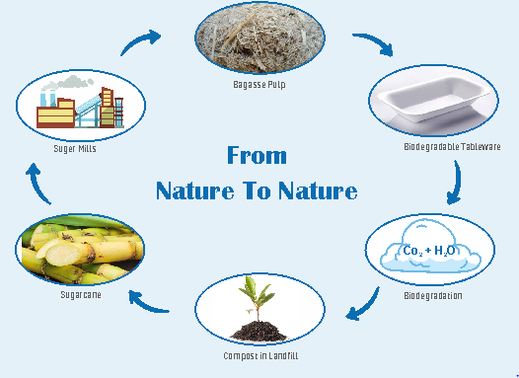

**CHAPTER 5**

**PROJECT EXPLANATION**

* **Fiber source**

The plants, which produce natural fibers, are classified as primary and secondary depending on their utilization. Primary plants are those grown for their fiber content while secondary plants are plants in which thefibers are produced as a by-product. Jute, hemp, kenaf, and sisal are examples of primary plants. Pineapple, Bagasse, oil palm and coir are examples of secondary plant

### **The complete process of raw material to finished tableware**

### **is carried out in the following sections –**

* Raw material
* Pulping station
* Forming station
* Trimming station
* Molding station
* Mesh making
* Maintenance
* QC and packaging
* Finished goods
* Thermic fluid heater
* Mesh cleaning
* Cooling tower
* Air compressor system
* Vacuum system

**1. PULP MOLDING PRODUCTION MACHINE:**

Bagasse is the by-product of the sugar industry and is also one kind of papermaking fiber material. As the foundation of paper and pulp industry, fiber materials include wood fiber and straw fiber. Except for the sugarcane bagasse, there are some other materials like wheat straw, reed, bamboo, and kenaf, etc. Among all kinds of fiber materials, bagasse is low-cost and inexhaustible to make paper pulp. The bleached bagasse pulp can be mixed to certain quantity of macrofiber and used to manufacture various high-grade cultural paper and living paper, such as bodystock paper, copy paper, two-side offset paper, sanitary tissue, napkin and etc. With the proper manufacturing process, the bagasse pulp also can be applied to make coated art base paper or newspaper.Sugarcane is annual rhizomatous plant, the average length of fiber is usually 1047-3.04mm. After squeezing, the length of bagasse fiber is similar to the hardwood fiber, is 1.0-2.34mm.

Bagasse pith is a parenchyma cell, it reduces the opacity and strength of paper, and increase the chemicals consumption and difficulty of manufacture. So the depithing is important for bagasse pulping.Sugarcane bagasse belongs to the straw fiber, is easy to cook or bleach and requires fewer chemicals consumption. Because silicon content of bagasse is lower than other straw fibers, which decide the bagasse pulp process or equipment is more mature and easy.

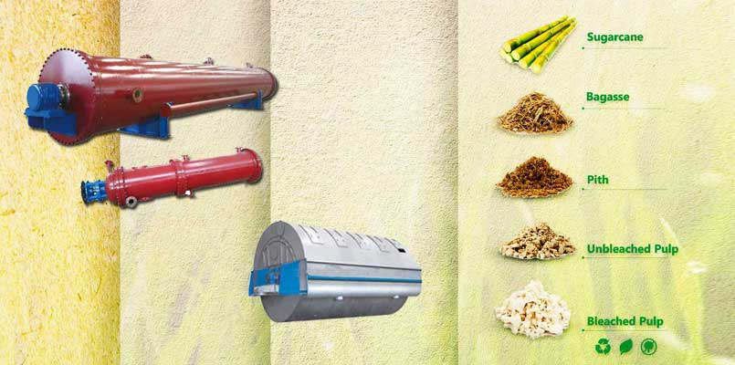

\

Bagasse is the by-product of the sugar industry and is also one kind of papermaking fiber material. As the foundation of paper and pulp industry, fiber materials include wood fiber and straw fiber. Except for the sugarcane bagasse, there are some other materials like wheat straw, reed, bamboo, and kenaf, etc. Among all kinds of fiber materials, bagasse is low-cost and inexhaustible to make paper pulp.

* **BAGASSE PULP PROCESSING:**

Bagasse pulp process includes materials preparation, pulp cooking, pulp washing, pulp screeningand pulp bleaching. Material preparation

Traditional bagasse preparation can be divided into three steps. Firstly, do the first half-dry depithing in the sugar factory. Secondly, after depithing, package the materials to the paper mill and stock through dry method. Thirdly, use the vertical or horizontal depithing machine deal the bagasse with the dry method of depithing, and the certified bagasse fiber for paper making is prepared.

In the modern sugarcane bagasse stocking, it usually uses wet storage to replace the dry storage. Wet storage can keep the bagasse wet, the water content is 70-80%, and both control bagasse fermentation and keep high stock per unit area. After wet storage and pulp washing, the bagasse has features of good fiber quality and quick penetration of cooking liquor, which decide the quality of bagasse paper. The wet storage advantages as follow:

* Avoids the color and whiteness of bagasse pulp getting bad.
* Improve the quality of bagasse pulp.
* Reduce the chemicals consumption and storage loss.
* Avoid the bagasse blowing and fire disaster.

**2. SEMI AUTOMATIC FORMING MACHINE (PFMV1)**

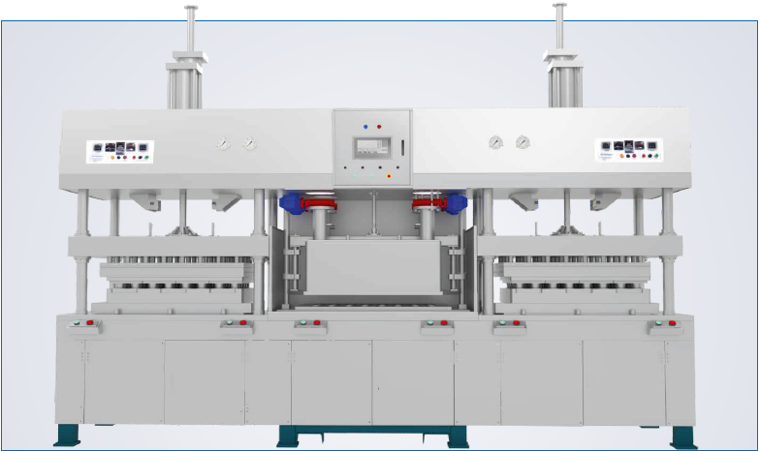

Figure 2.6 Savonius Turbine

To utilize the available wind resources and to reduce the usage of non-renewable energy resources.Wind energy is by far the fastest-growing renewable energyresource.The wind energy industry so far has been supported by market incentivesbacked by government policies fostering sustainable energy resources. Large-scale wind facilities approaching the output rating of conventional powerplants, control of the power quality is required to reduce the adverse effectson their integration into the network

Parason's Semiautomatic

Forming machine (PFMV2) is the most advanced technology in this type of forming

machine segment. Self contained technology for forming and drying of products is equipped with floating distribution type of pulp inlet system which ensures accurate pouring of pulp onto the mold. Benefits in uniform formation of products throughout the platen.

|  |  |
| --- | --- |
| Capacity | 500 kgs/day |
|  |  |
| Forming | 1 station |
| Hot press | 2 station |
| Platen size | 1000*950 mm |
| Mold | Special grade alloy |
| Dual heating mode | Electric & Thermal oil |
| Electric heating load | 90 kw |
| Thermal oil heating load | 0.3 kw |
| Control system | PLC with HMI |
| Drive | Air liquid booster system |
| Forming type | Effusion |
| Max Product Height | 150 mm |

## **Advantages Of Parason Molded Fiber Production Line**

### **Features**

* Suitable for manual and robotic operation
* In-mold drying of products
* Machine body, pulp, and water contact parts are of SS304
* Safety curtain for the safety of the operator
* Four pillar guided molds with precise locking mechanism
* Economical setup to start with lower capacity
* Dual drive ensures stable platen movement at a higher speed
* No requirement of back water inlet in machine
* Stationery pulp inlet system
* Platen locking mechanism
* Suitable for manual and robotic operation

**3. MOLDED FIBER EDGE TRIMMING MACHINE:**

|  |
| --- |
|  |

Parason Edge Trimming Machine gives the molded fiber products a fine edge finish with dimensional accuracy. This heavy-duty machine is specifically designed for longer duration operation, compatible for wide range of tableware products and a stand-alone application.

Machine customization available for different platen sizes.

* Sensor for stroke counng and height adjustment depending upon the product's requirement
* Compact and sturdy design to withstand high pressure
* Precisely set molds and blades High pressure
* enables single­shot and quick cung of mulple products
* Safety curtain for safety of operator

## **ADVANTAGES OF PARASON EDGE TRIMMING MACHINE**

## 

## **Features (Hydraulic)**

1. Energy efficient motor
2. Stand-alone application
3. No requirement of compressed air
4. Compact and sturdy design
5. Sensors for stroke counting and height
6. Adjustment to suit product needs
7. Safety light curtains for operator's safety

* **Features (Hydro-pneumatic)**

### Less motor power load at machine

### High speed

### Compact and sturdy design

### Sensors for stroke counting and height

### adjustment to suit product needs

### Safety light curtains for operator's safety

### Lesser maintenance

|  |  |
| --- | --- |
| Models | Hydraulic /Hydro pneumatic |
|  |  |
| Platen size | 760*600 mm |
| Electrical load | 3.7 kW (Hydraulic model) |
| Operation | Push button |
| Electrical panel | Side mounted |
| C  overs | 3 Sides protected |
| Product height | Max. 100 mm |

|  |  |
| --- | --- |
| Food container | Dishware, tableware, lunch box, bowl… |
| Artware | Mask, Christmas balls, Easter Eggs , boutiques… |
| Disposable Medical Care Products | Bedpan, sick pad, female urinal… |
| High quality packages | Mobile phone package, camera package, |

**4. MOLDED FIBER PRODUCTION MOLD :**

|  |
| --- |
|  |

**Features**

* Ergonomic & economical design
* Non-corrosive special grade alloy
* Nons-sticky surface finish
* Cutting-edge product geometry keeps trimming waste minimum
* Robust grilled underneath structure to provide strength
* Option for detachable branding attachment
* Precise machining and weight distribution
* Mold customization & fast delivery

## **Production Molds ;**

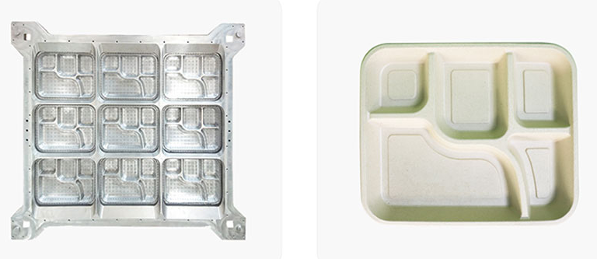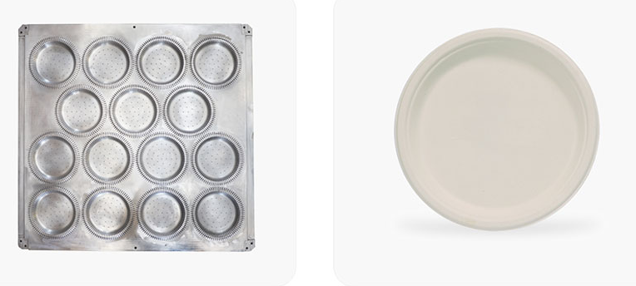

## **Moulded Fibre Product List:**

| **Sr. No.** | **Product** | **Size** | **Weight (gm)** |
| --- | --- | --- | --- |
| 1 | Round plate 12” 4CP | 3ࣺ04x27 | 30 |
| 2 | Round plate 12” Plain | 3ࣺ04x27 | 29 |
| 3 | Round plate 11” 4CP | 279x27 | 25 |
| 4 | Round plate 11” Plain | 279x27 | 25 |
| 5 | Round plate 10” 3CP | 254x20 | 20 |
| 6 | Round plate 10” Plain | 254x20 | 20 |
| 7 | Round plate 9” 3CP | 229x20 | 15 |
| 8 | Round plate 9” Plain | 229x20 | 15 |
| 9 | Square plate 6” | 152x152 | 7.5 |
| 10 | Meal tray 5CP | 305x248x30 | 32 |
| 11 | Meal tray 4CP | 300x248x30 | 30 |
| 12 | Meal tray 3CP | 220x202x25 | 20 |
| 13 | Oval tray | 190x253x20 | 13 |
| 14 | Bowl (Dip) 50 ml | 63x18 | 3 |
| 15 | Bowl 120 ml | 100x40 | 5 |
| 16 | Bowl 180 ml | 110x45 | 6.1 |
| 17 | Bowl 240 ml | 115x46 | 6.5 |
| 18 | Bowl 360 ml | 130x45 | 8.3 |
| 19 | Clamshell 6” square | 152x301x45 | 20 |
| 20 | Clamshell 8” square plain | 203x400x45 | 40 |
| 21 | Clamshell 8” square 3CP | 203x400x45 | 40 |
| 22 | Cup 220 ml | 90x77 | 6.5 |
| 23 | Cup 250 ml | 90x81 | 7 |
| 24 | Container 500 ml | 240x125x30 | 24 |
| 25 | Container 600 ml | 150x50 | 25 |
| 26 | Container 750 ml | 238x150x45 | 27 |
| 27 | Container 1000 ml | 245x150x50 | 29 |

***Sustainable bio-degradable tableware can be catered to the following industries*-**

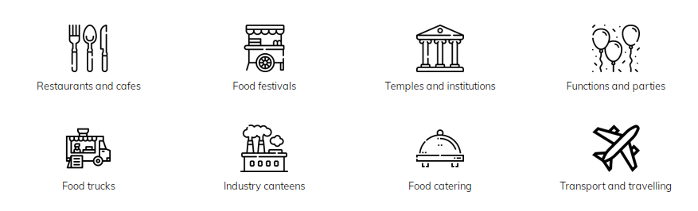

|  |
| --- |
| **C:\Users\Ajay\AppData\Local\Microsoft\Windows\INetCache\Content.Word\fedfh.png** |

***Features of Parason engineered solutions produced tableware -***

**CHAPTER 6**

**RESULTS AND CANCLUSION**

Major driving force to witness the significant research and development and industrial efforts on molded fiber technologies. This work gives overview of the plastic waste challenges and molded pulp products as alternatives to these non-degradable, non-sustainable oil-based traditional plastic packaging products. The main concepts involved in the molded pulp packaging industry, from the general manufacturing process to current and emerging areas of molded pulp technology, were reviewed.

Molded fiber technologies/ products and their industrial exploitation are rapidly evolving, both scientific knowledge and engineering design/practices, from the environmental advantages to cost-effectiveness, are critical in unlocking the true potential of molded fiber products for various packaging applications. The following are some examples of these topics that could be tackled:

(1) The driving force of molded fiber technologies/ products is largely driven by their green/ sustainable advantages. Therefore, the choices of raw fiber sources, the technologies on fiber preparations (enzymatic, mechanical, chemical, energy consumption, waste generated, post consumption treatment, etc.), will have to be carefully evaluated and optimized because they will certainly determine the environmental impact of the final molded fiber products and their overall manufacturing processes.

(2) Fundamental research will be required to impart desirable features to cellulosic/ lignocellulosic fibers for specific MFPs. For example, in many applications, such as food packaging, a high transparency, yet with high barrier properties on these molded pulp products are required. Further research in resolving these challenges but also with cost-effective solutions, will be desirable.

(3) Market do exist for different MFPs, some are in large volume/ low value, while others are in small volume/ high value. Large volume/ low value molded pulp products, such as coffee/drink carrier trays, picnic plates, are already common in the market; however, small volume/high value for niche applications, for example, packaging of medicine/pills, cosmetics, are yet to be developed, which certainly require more research and development efforts.

(4) Process development and optimization, especially for the dewatering and drying technologies are highly needed. For instance, exploiting some more efficient additives to increase dewatering efficiency, and understanding the mechanism of the novel impulse drying process so that the drying and energy efficiency of the precision molded products can be significantly boosted.

(5) In order to completely understand the environmental sustainability of molded products, further specific studies on their life cycle should be carried out based on LCA method, in particular for those key stages of pulp preparation and product production (such as the drying process) that are the most contributing life-cycle stages.

**CHAPTER 6**

**FUTURE SCOPE**

The MFPs are used with the intent to be discarded after single use post-consumption usage. With the unique advantage of being molded into desired shapes, this feature allows for a broad range of markets, which are categorized into three main branches: industrial packaging, disposable items and food-related products

In industrial packaging, a prime example of molded pulp application is in the electronics market and house hold items. Currently, the packaging material of the industrial market is dominated by expanded polystyrene (EPS), one of the most detrimental material to the environment. Molded pulp has comparable properties to EPS (Table 5) and can be used as a suitable replacement of EPS. In addition, the cushioning efficiency of molded pulp products relies on geometry and design, thus, the customizability properties allow the industrial packaging products to be of various sizes, suitable for small-, medium- or large- scale operations.

| Empty Cell | **Molded fiber** | **EPS** |
| --- | --- | --- |
| **Material** | Plant fiber | Petroleum based polystyrene |
| **Environment** | Sustainable that is fully recyclable and biodegradable | Non-biodegradable material facing bans in many countries |
| **Economic** | Stable cost bases | Not stable, prices are correlated to rising oil and resin prices |
| **Protection** | Outstanding vibration & cushioning | Good vibration & cushioning |
| **Shipping & storage** | Product nests | Product rarely nests |
| **Temperature tolerance** | Unaffected by extreme temperature | Temperature affects flexibility |

The MFPs are on the rise to replace the conventional [plastic products](https://www.sciencedirect.com/topics/materials-science/plastic-product) for the various packaging purposes, and the environmental incentive has been largely the driving force. It is expected that such a trend will continue. Companies such as Carlsberg, Zume, E-Molding and Pactiv are some fine examples that have been striving for developing and providing innovative products by applying molded pulp technologies for the packaging purpose that covers industrial packaging, disposable items and food-related products. They all have the common ambitions to reduce waste and carbon emissions while also help companies thrive in an increasingly convenience and sustainable development- driven system.

When it comes to the environmental sustainability of MFP, it is essential to have a general idea of its life cycle since it has been recognized as basic assessment information for sustainability. Essentially, one popular method for assessing the environmental impact of a product during its entire life cycle is [LCA](https://www.sciencedirect.com/topics/agricultural-and-biological-sciences/life-cycle-assessment).

**CHAPTER 7**

**REFERENCES**

1 . Saratale, G.D.; Oh, M.-K. Improving alkaline pretreatment method for preparation of whole rice waste biomass feedstock and bioethanol production. RSC Adv. 2015, 5, 97171–97179. [CrossRef]

2. Saratale, G.D.; Jung, M.Y.; Oh, M.K. Reutilization of green liquor chemicals for pretreatment of whole rice waste biomass and its application to 2,3-butanediol production. Bioresour. Technol. 2016, 205, 90–96. [CrossRef]

3. Tayeb, A.H.; Amini, E.; Ghasemi, S.; Tajvidi, M. Cellulose Nanomaterials-Binding Properties and Applications: A Review. Molecules 2018, 23, 2684. [CrossRef] [PubMed]

4. Didone, M.; Saxena, P.; Brilhuis-Meijer, E.; Tosello, G.; Bissacco, G.; McAloone, T.C.; Pigosso, D.C.A.; Howard, T.J. Moulded Pulp Manufacturing: Overview and Prospects for the Process Technology. Packag. Technol. Sci. 2017, 30, 231–249. [CrossRef]

5. Kong, W.Q.; Wang, C.W.; Jia, C.; Kuang, Y.D.; Pastel, G.; Chen, C.J.; Chen, G.G.; He, S.M.; Huang, H.; Zhang, J.H.; et al. Muscle-Inspired Highly Anisotropic, Strong, Ion-Conductive Hydrogels. Adv. Mater. 2018, 30, 7. [CrossRef] [PubMed]

6. Hosseini, S.B.; Hedjazi, S.; Jamalirad, L. Investigation on physical and mechanical properties of pulp-plastic composites from bagasse. Wood Mater. Sci. Eng. 2017, 12, 279–287. [CrossRef]

7. Lange, C.; Touaiti, F.; Fardim, P. Hybrid clay functionalized biofibres for composite applications. Compos. Part B Eng. 2013, 47, 260–266. [CrossRef]

8. Lerche, H.; Benthien, J.T.; Schwarz, K.U.; Ohlmeyer, M. Effects of Defibration Conditions on Mechanical and Physical Properties of Wood Fiber/High-Density Polyethylene Composites. J. Wood Chem. Technol. 2014, 34, 98–110. [CrossRef]

9. Joseleau, J.P.; Chevalier-Billosta, V.; Ruel, K. Interaction between microfibrillar cellulose fines and fibers: Influence on pulp qualities and paper sheet properties. Cellulose 2012, 19, 769–777. [CrossRef]

10. Wang, J.J.; Wang, B.; Liu, J.L.; Ni, L.; Li, J.Z. Effect of Hot-Pressing Temperature on Characteristics of Straw-Based Binderless Fiberboards with Pulping Effluent. Materials 2019, 12, 922. [CrossRef] [PubMed]

<https://parason.com/products/molded-fiber/edge-trimming-machine/>

<https://www.moldedpulpengineering.com/applications/>

<https://bioresources.cnr.ncsu.edu/resources/molded-pulp-products-for-sustainable-packaging-production-rate-challenges-and-product-opportunities/>

<https://www.sciencedirect.com/science/article/pii/S2369969821000803>

<https://link.springer.com/chapter/10.1007/978-981-16-4233-3_5>